OOP PROJECT
Project: Aura Retail OS (Sub Task – 2)
Group 11 - ABSTRACT MIND

Team Members:
Jay Shah – 202512059
Priya J Shah – 202512100
Priya D Shah – 202512105
Jenil Shah – 202512110

Index
Sr. No | Title | Page
1 | Index | 2
2 | Partial source code | 3
3 | Implemented Design Patterns | 4
4 | Basic working simulation | 6
5 | Github repo link with source code | 9
6 | Updated class diagram | 9

Partial source code
  - Link: https://github.com/priiyu12/Aura-Retail-OS
  - For Subtask 2, we have implemented a partial C++ prototype of our smart-city kiosk platform. The prototype currently includes the main subsystems: Kiosk Core System, Inventory System, Payment System, Hardware Abstraction Layer, Pricing System, Event System, and Monitoring System, following the modular architecture required in the project brief.
  - The prototype supports an interactive simulation where the user can select User Mode or Admin Mode, choose one of the four kiosk environments - Hospital, Metro, University, or Disaster Relief - and perform actions such as viewing products, purchasing items, restocking inventory, and running diagnostics. The system also demonstrates stock checking, dynamic price calculation, payment processing, hardware dispensing, and event-based alerts such as low stock and hardware failure.
  - At this stage, advanced components such as Command, Memento, Central Registry, persistence, and full kiosk factory support are intentionally kept for the final implementation phase. This repository therefore represents a working prototype for Subtask 2, satisfying the requirement of partial code, implemented patterns, and a basic working simulation.

Implemented Design Patterns

Facade Pattern
- The Facade Pattern provides a simple interface to a complex subsystem.
- In our project, KioskInterface acts as the facade, giving users and admins a single entry point for actions like purchaseItem(), refundTransaction(), runDiagnostics(), and restockInventory(). Internal operations are coordinated by KioskCoreSystem, while subsystems such as InventorySystem, PaymentSystem, HardwareLayer, PricingSystem, and EventBus remain hidden.
- This makes the system easier to use, reduces coupling, and improves modularity.
- Class Mapping:
KioskInterface → acts as Facade
KioskCoreSystem → processes and coordinates subsystem operations
InventorySystem, PaymentSystem, HardwareLayer, PricingSystem, EventBus → internal subsystems hidden behind the facade

Strategy Pattern
- The Strategy Pattern allows algorithms to be defined separately and switched at runtime.
- In our project, pricing is implemented using a PricingStrategy interface. StandardPricing is the current concrete strategy, while DiscountPricing and EmergencyPricing are planned extensions. The PricingSystem acts as the context and uses the selected strategy to calculate product prices dynamically.
- This keeps pricing logic flexible, reusable, and easy to extend.
- Class Mapping:
PricingStrategy → strategy interface
StandardPricing → concrete strategy implemented in Subtask 2
DiscountPricing, EmergencyPricing → planned strategies for future extension
PricingSystem → context class that uses the current strategy

Observer Pattern
- The Observer Pattern allows objects to be notified automatically when events occur.
- In our project, EventBus acts as the publisher, while EventListener defines the observer interface. CityMonitoringSystem is a concrete observer that receives alerts for events such as LowStockEvent and HardwareFailureEvent, produced by KioskCoreSystem, InventorySystem, or HardwareLayer.
- This reduces direct dependencies and enables loose, event-driven communication between subsystems.
- Class Mapping:
EventBus → subject / publisher
EventListener → observer interface
CityMonitoringSystem → concrete observer
LowStockEvent, HardwareFailureEvent → event types
KioskCoreSystem / InventorySystem / HardwareLayer → event producers

Basic working simulation

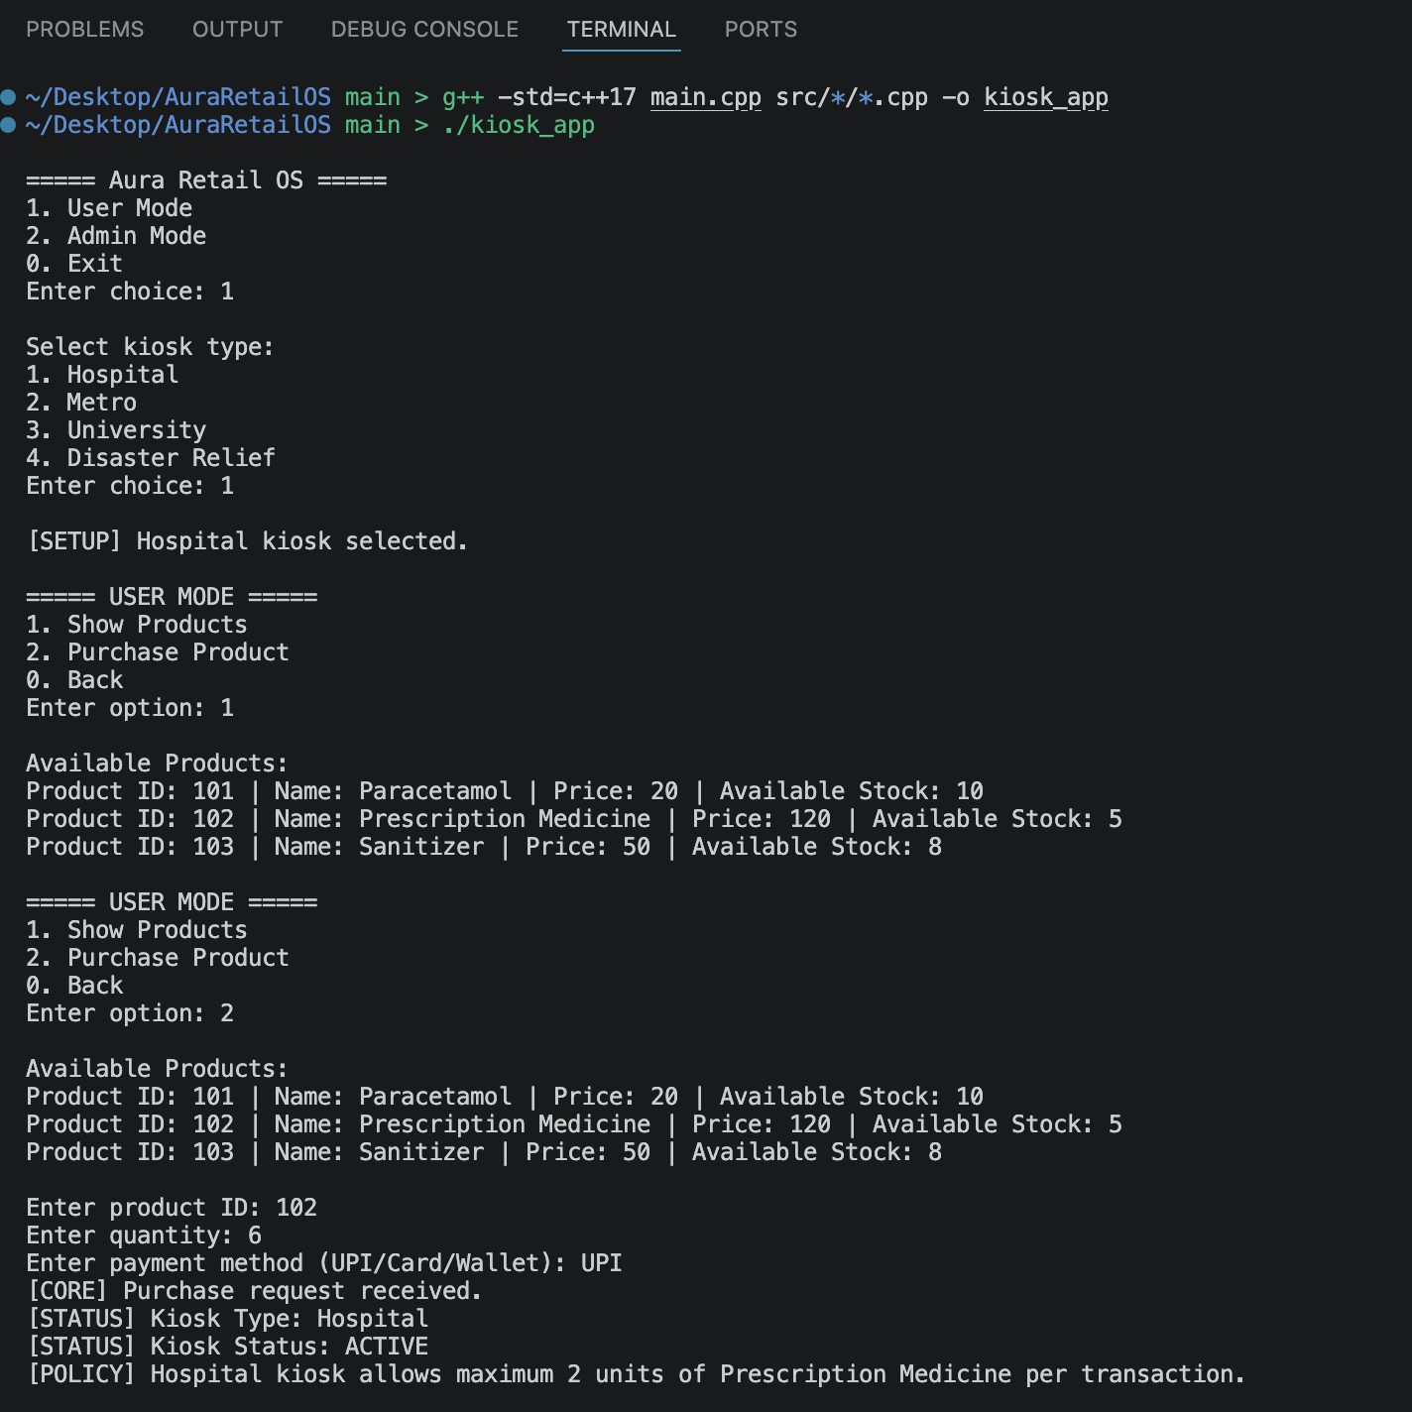

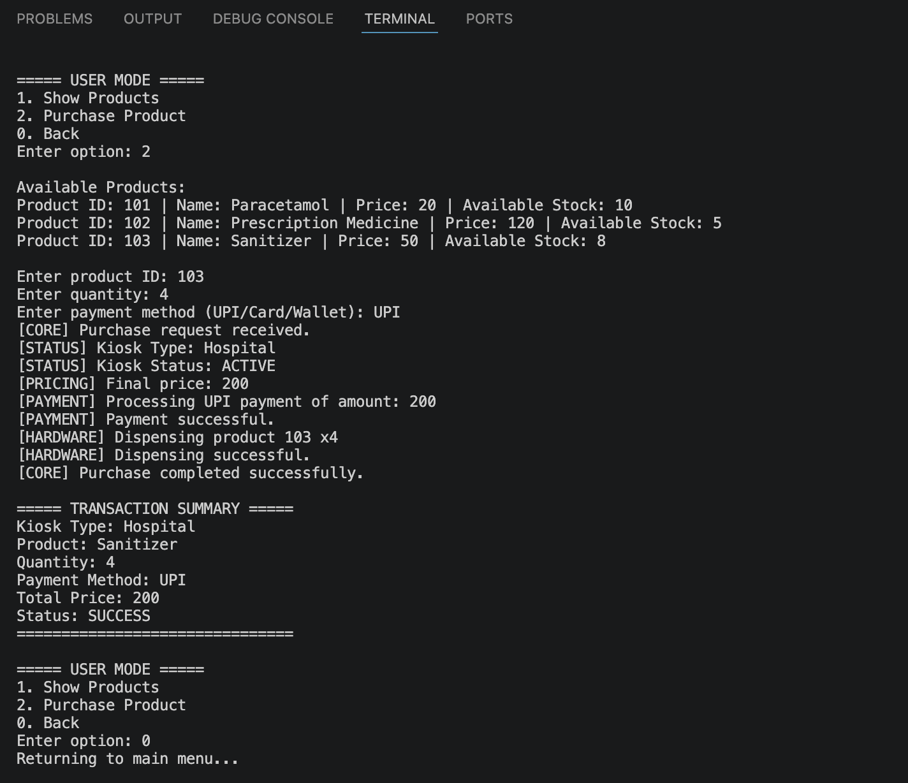

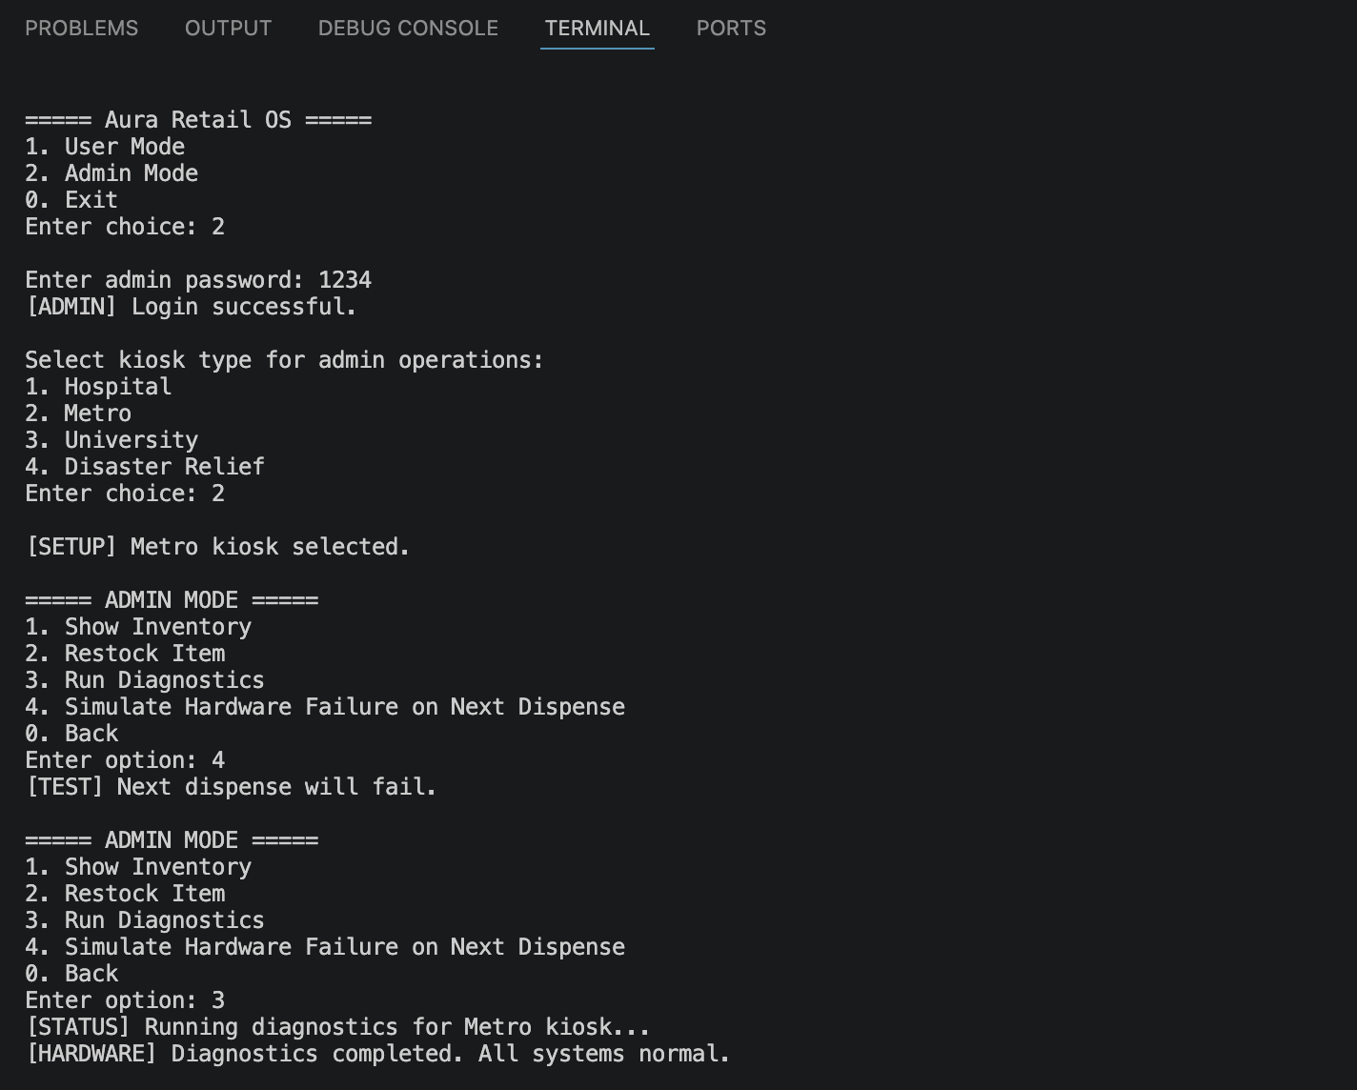
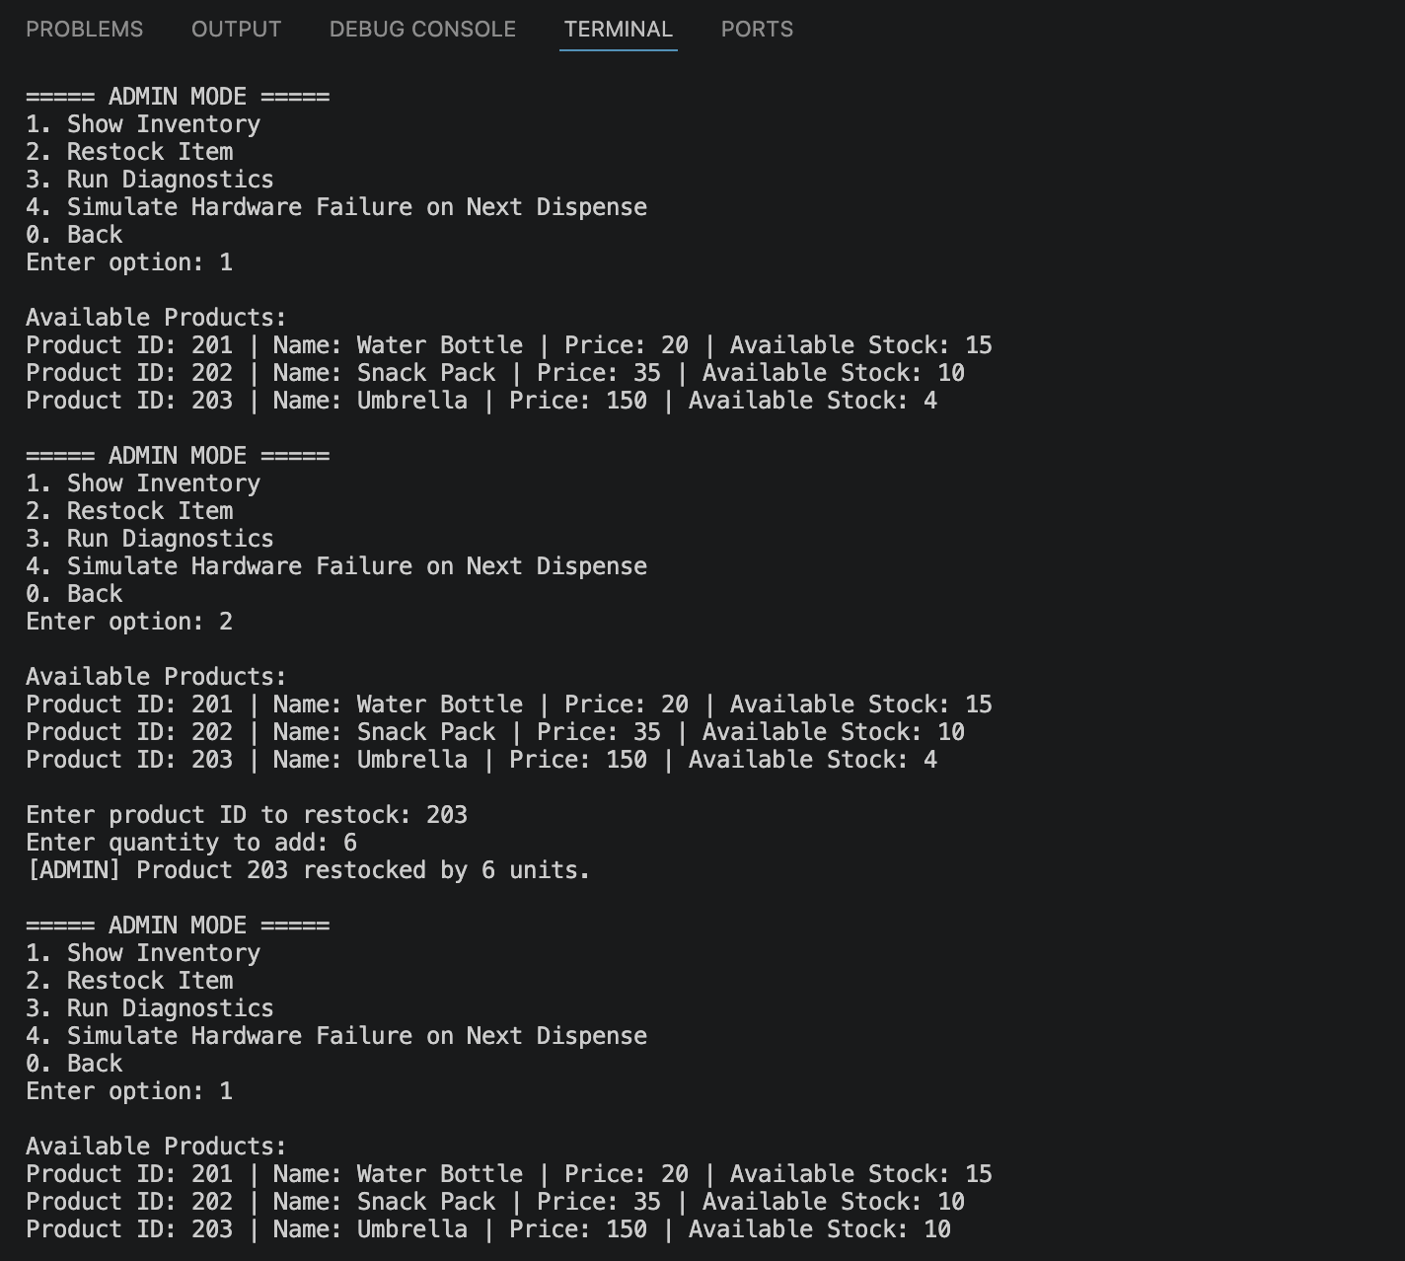

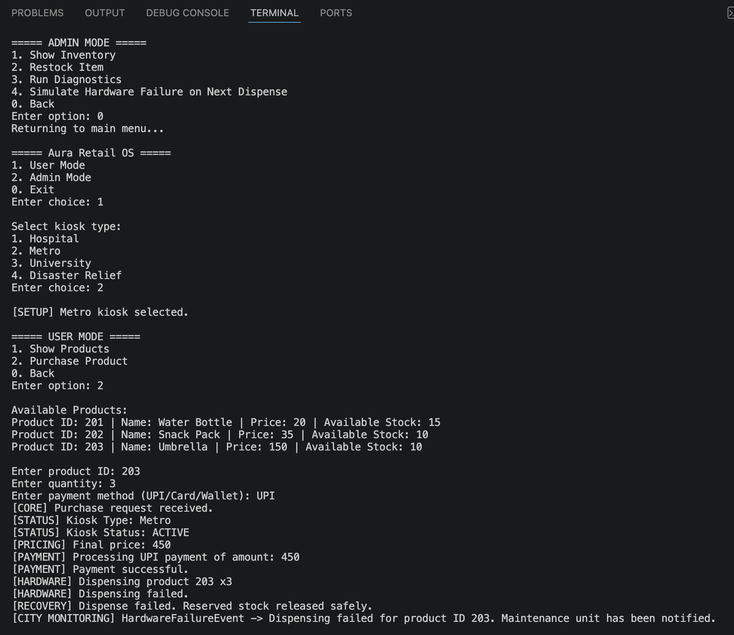

Github repo link with source code
  - Link: https://github.com/priiyu12/Aura-Retail-OS

Updated class diagram
  - Link: https://viewer.diagrams.net/?tags=%7B%7D&lightbox=1&target=self&highlight=0000ff&edit=_blank&layers=1&nav=1&title=Class%20Diagram%20OOP.svg&dark=0#Uhttps%3A%2F%2Fdrive.google.com%2Fuc%3Fid%3D1Ef52tq8TPa8FvYuSJ7qPgi8ZHWj3ZiPN%26export%3Ddownload

